**GIT Homework**

**Student:** Rytis Svinkūnas

**Task:** make merge conflict and solve it.

1. Created new branch “six” and committed new file “six.php”

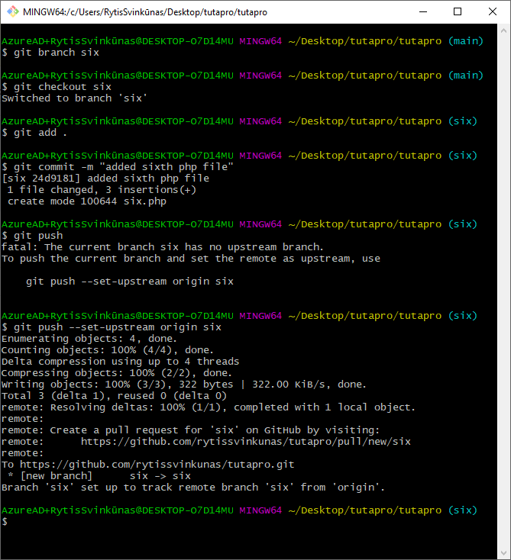

1. Checkout to “main” branch and created new branch “six-alternative” and committed new file “six.php”

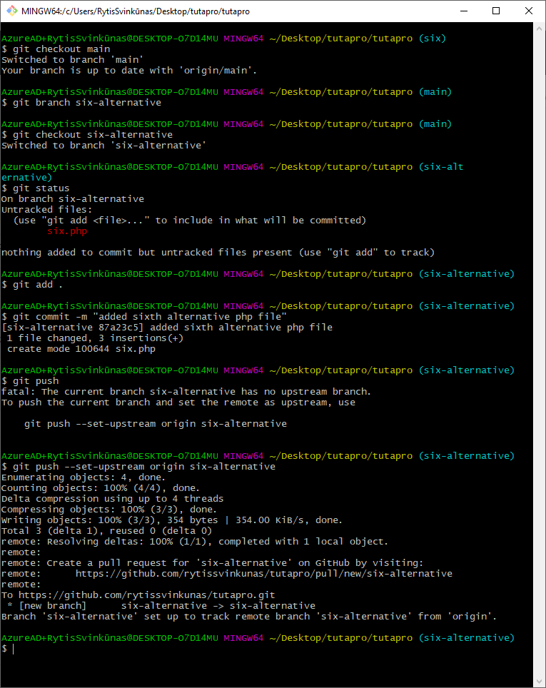

1. Checkout to “main” branch and merged “six” branch to “main” branch. Also tried merge “six-alternative” branch to “main” and got merge conflict.

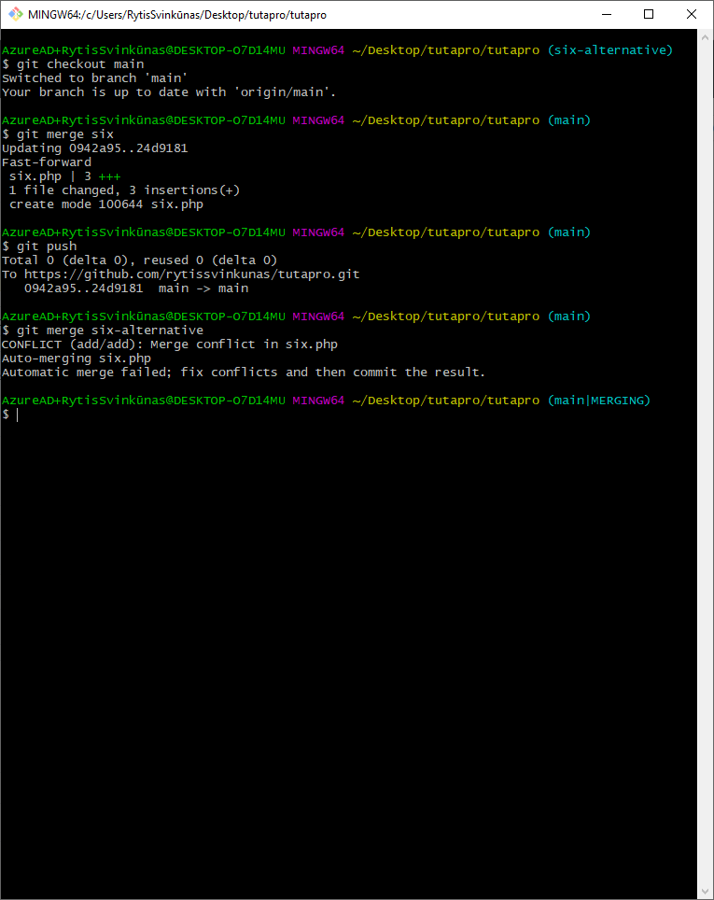

1. File “six.php” with conflict

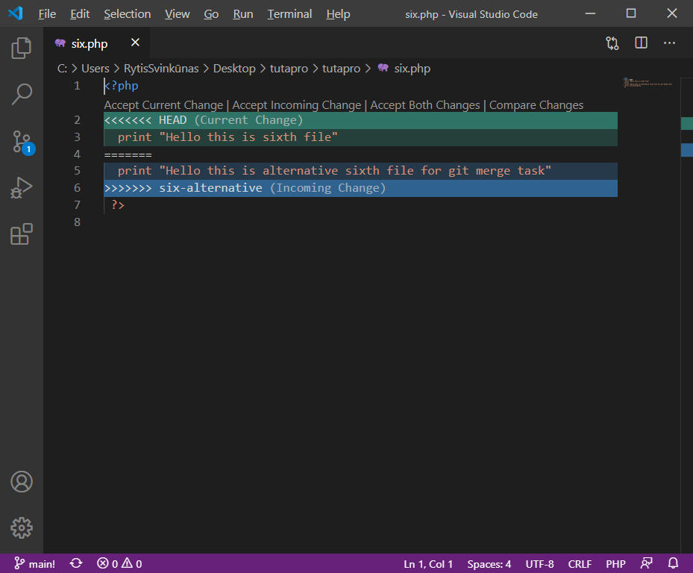

1. Solved conflict and Accepted Incoming Changes file “six.php”

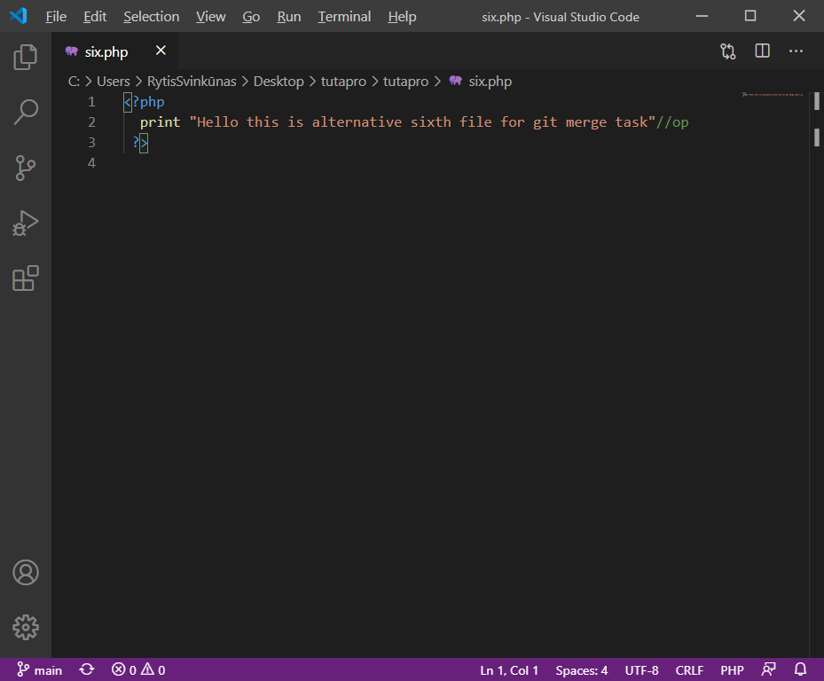

1. Committed and pushed changes to “main” branch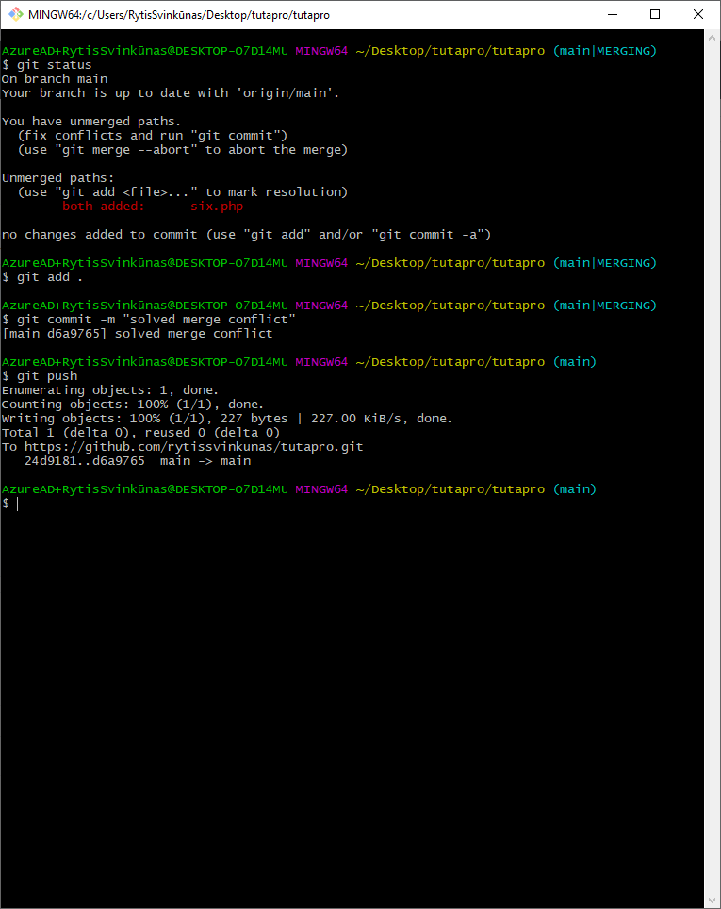
2. Can see changes in GitHub

